**Solid Principle:**

The SOLID Principles are five principles of Object-Oriented class design. They are a set of rules and best practices to follow while designing a class structure.

These five principles help us understand the need for certain design patterns and software architecture in general

* The **S**ingle Responsibility Principle
* The **O**pen-Closed Principle
* The **L**iskov Substitution Principle
* The **I**nterface Segregation Principle
* The **D**ependency Inversion Principle

Example with c#:



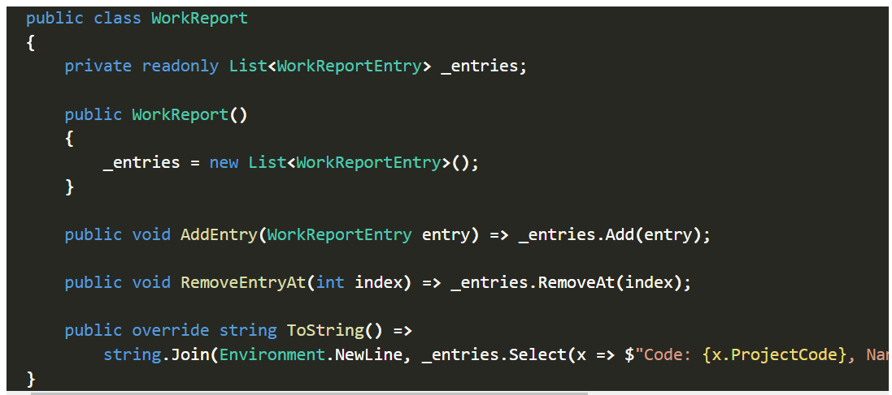

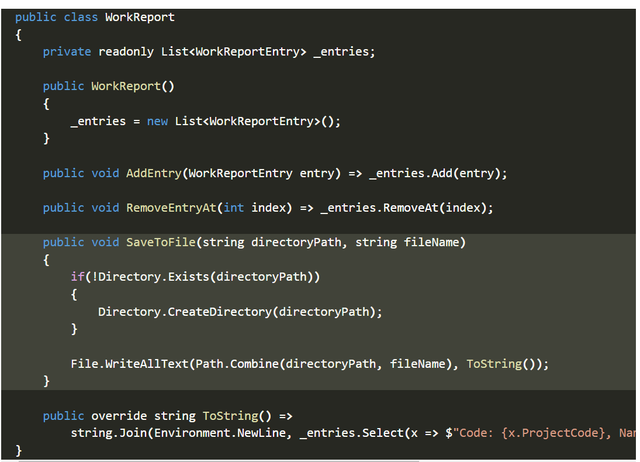

**Problems With This Code: It has more than one responsibility.**

## **Refactoring Towards SRP (single Responsibility principle):**

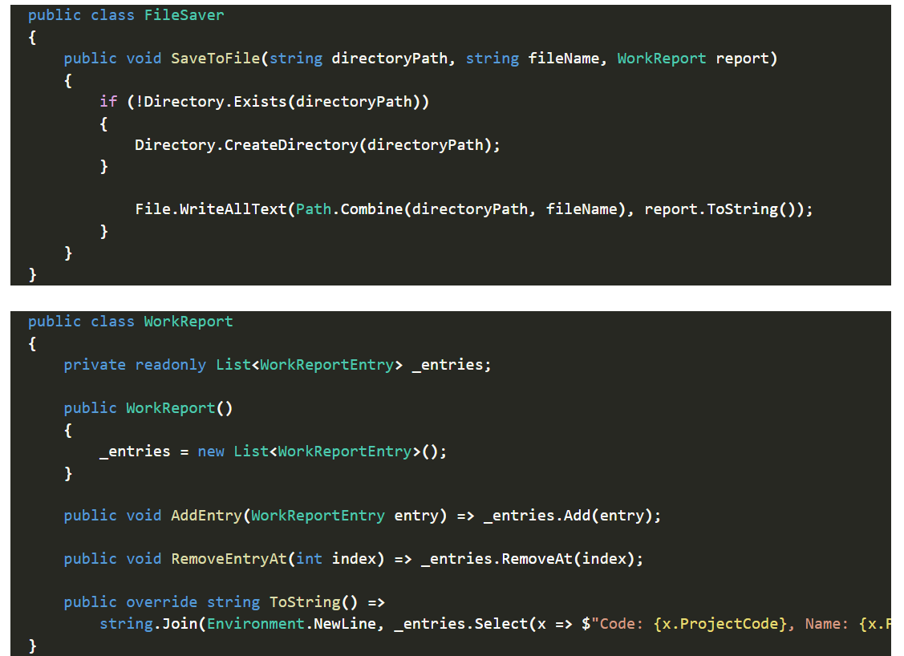

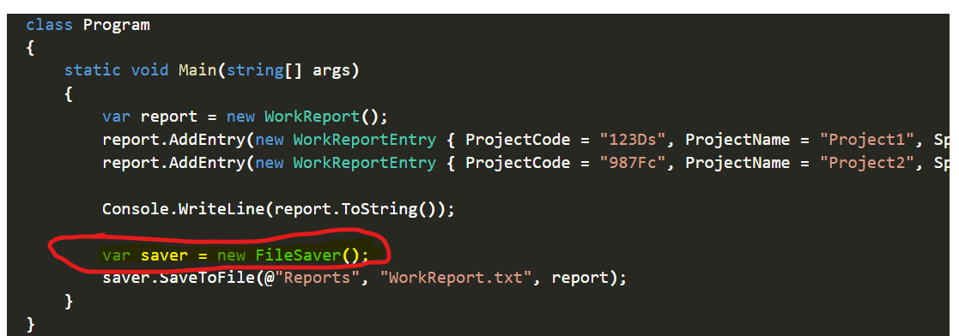

-every calss must be do a single responsibility and the function also !!..

So, we spereate savefile about workreport entity

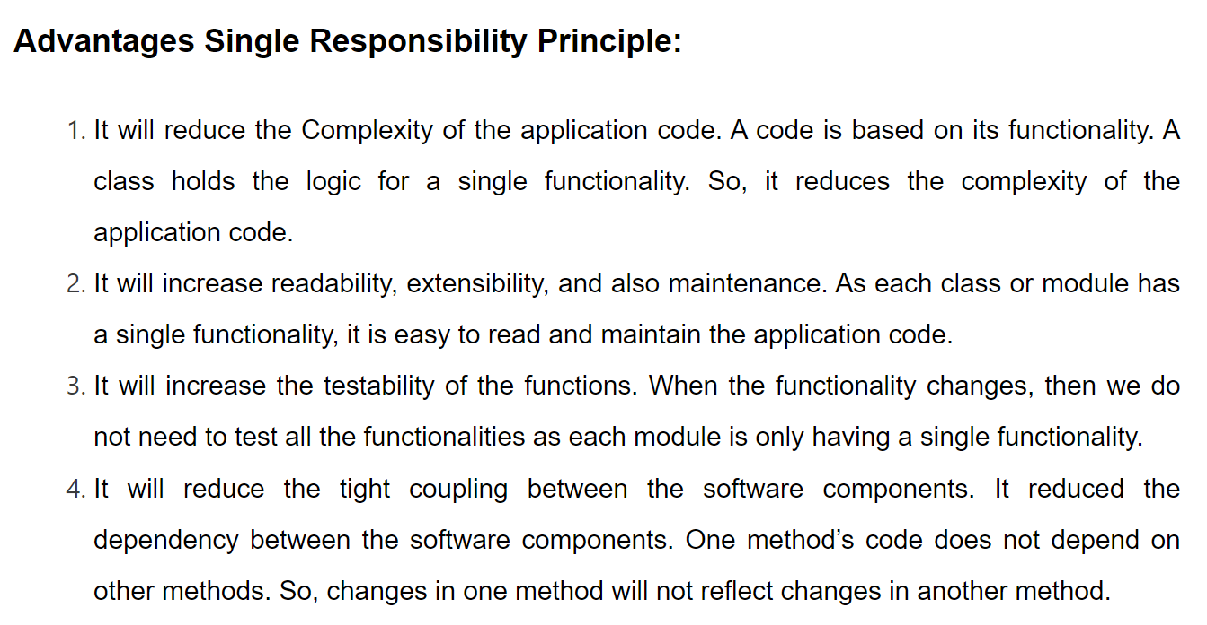

Resources:

<https://dotnettutorials.net/lesson/single-responsibility-principle/>

<https://code-maze.com/single-responsibility-principle/>